Published by | Editor

HEWI
Marketing + Innovation

HEWI Heinrich Wilke GmbH
Postfach 1260
D-34442 Bad Arolsen
Phone: +49 5691 82-0
presse@hewi.de
www.hewi.com

Reprint free - specimen copy requested

Security at Doors and Windows
Certified Burglar Resistant Solutions
The number of home burglaries increases continuously. In most cases the perpetrators get into the home through external doors or ground floor windows.
Security Escutcheons for External Doors
The burglar resistant effect of external doors, such as front doors or basement doors, can be increased significantly by fitting them with security escutcheons, which protect the lock. Security escutcheons are designed to make mechanical manipulation (lock drilling or forced lock-snapping) of the profile cylinder considerably more difficult and thus burglary can be prevented.
HEWI security escutcheons are conically shaped so that they cannot be forcefully twisted off. The bottom section is additionally hardened to increase the stability of the rose.
From April 2017, HEWI security escutcheons are optionally available made of polyamide-steel composite or stainless steel, they are certified according to DIN 18 257 Class 1. HEWI security escutcheons are suitable for use on burglar resistant doors (EN 1627 -1630). They have an additional anti-drilling plate in the area of the lock for increased security requirements.
Lockable Window Handles
HEWI window handles for locking enable windows to be opened only with a key. In addition, optional lockable window handles with a tilt-before-turn function are available. If the window handle is locked, when turned through 90° it releases the window for tilting. The window leaf cannot be completely opened (turned) in a closed function
The lockable window handles are certified by an independent test institute. They fulfil the requirements of resistance class RC 1-6 (protection against twisting off and forced lock-snapping). They are suitable for use on burglar resistant windows (EN 1627 -1630).

Design: HEWI

HEWI security escutcheons increase safety
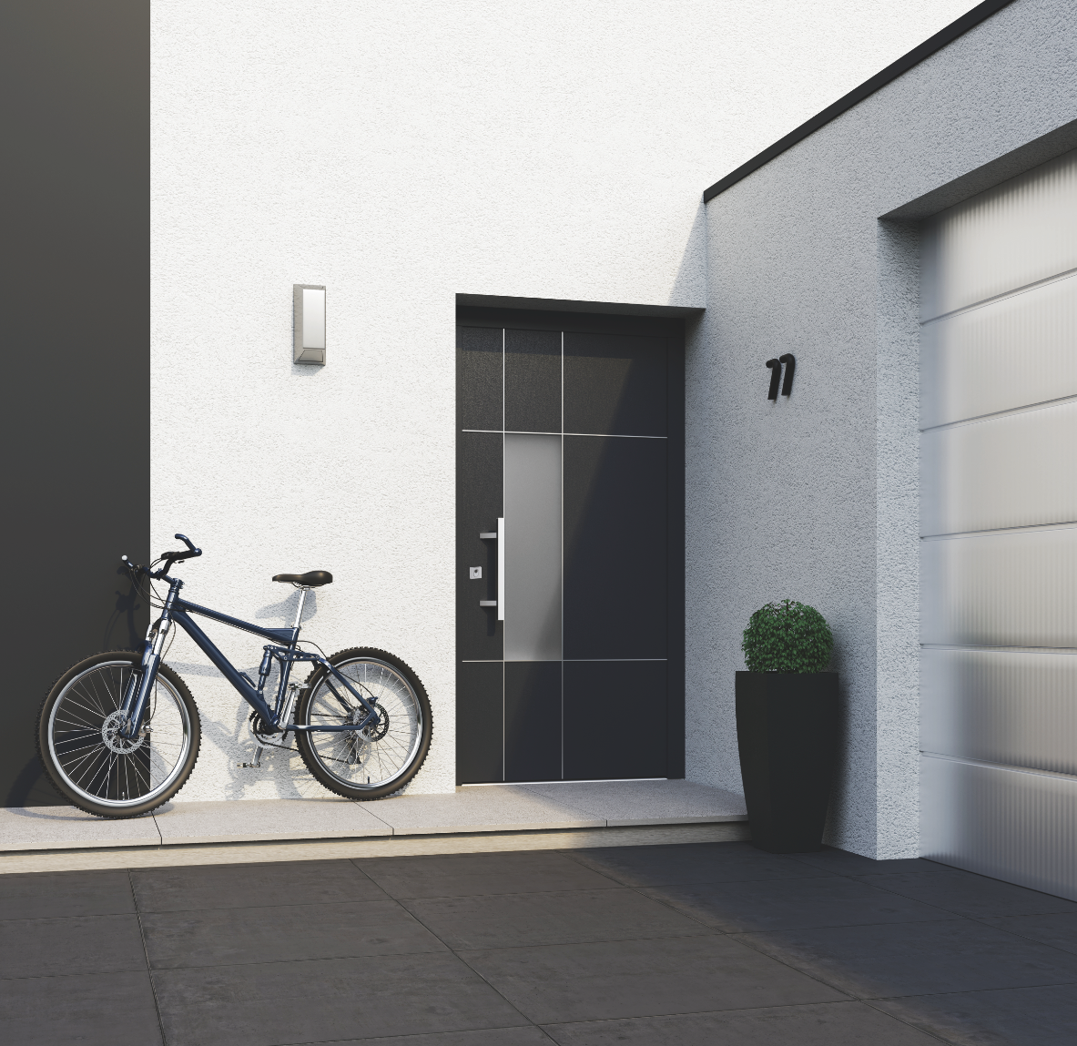
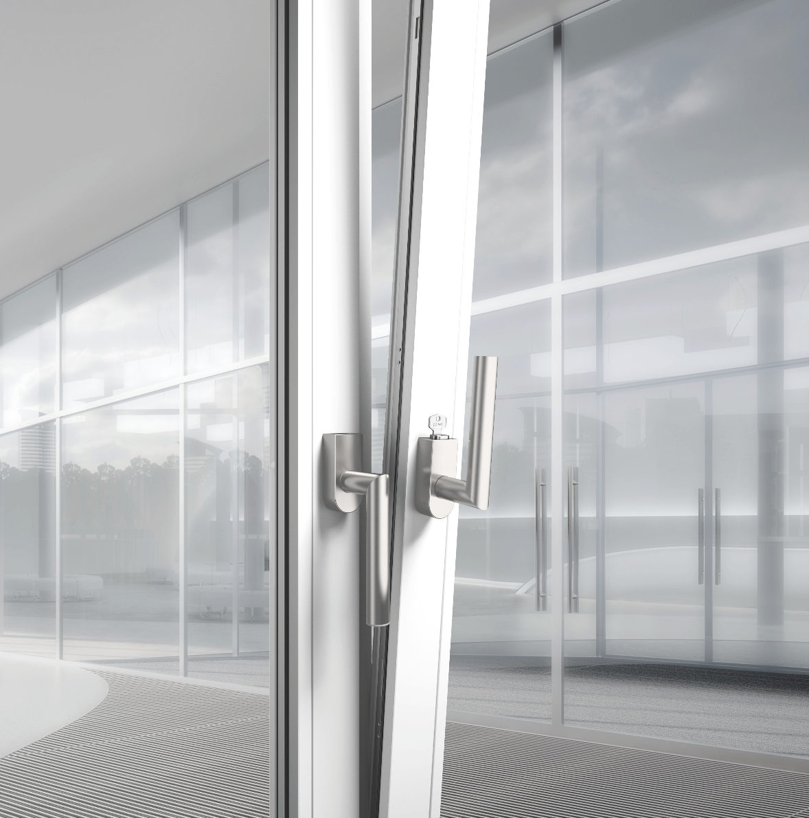

Certified security with lockable window handles from HEWI

Further information is available from:

HEWI Heinrich Wilke GmbH
Postfach 12 60
D-34442 Bad Arolsen
Phone +49 5691 82-0
Email: presse@hewi.de
Internet: www.hewi.com

